
EDA实验报告

课题名称： | 四位串行加法计数器
学 院： | 机电与信息工程学院
专 业： | 通信工程
年级班级： | 2012
姓 名： | 高楚阳
学 号： | 201200800568

- VHDL代码

(本代码与励晓崎同学合写，其中高写FBRAC.VHD,RFF1.VHD,励写DFF1.VHD,FADDER.VHD)

FBRAC.VHD
LIBRARY IEEE;
USE IEEE.STD_LOGIC_1164.ALL;
ENTITY FBRAC IS
PORT( aT:IN STD_LOGIC_VECTOR(3 DOWNTO 0);
bT:IN STD_LOGIC_VECTOR(3 DOWNTO 0);
sT:OUT STD_LOGIC_VECTOR(3 DOWNTO 0);
CINTOP:IN STD_LOGIC;
CLKTOP :IN STD_LOGIC;
COUTTOP : OUT STD_LOGIC);
END ENTITY FBRAC;
ARCHITECTURE ONE OF FBRAC IS
COMPONENT DFF1
PORT (D:IN STD_LOGIC;
CLK:IN STD_LOGIC;
Q:OUT STD_LOGIC);
END COMPONENT DFF1;

COMPONENT RFF1
PORT(CLK :IN STD_LOGIC;
R : IN STD_LOGIC_VECTOR(3 DOWNTO 0);
Q : OUT STD_LOGIC_VECTOR(3 DOWNTO 0));
END COMPONENT RFF1;
COMPONENT bit4_f_adder
PORT(aa:IN STD_LOGIC_VECTOR(3 DOWNTO 0);
bb:IN STD_LOGIC_VECTOR(3 DOWNTO 0);
cin:IN STD_LOGIC;
cout:OUT STD_LOGIC;
ss:OUT STD_LOGIC_VECTOR(3 DOWNTO 0));

END COMPONENT bit4_f_adder;
SIGNAL E,F,G: STD_LOGIC_VECTOR(3 DOWNTO 0);
SIGNAL D1 :STD_LOGIC;
BEGIN
U1: RFF1 PORT MAP(R=>aT,Q=>E,CLK=>CLKTOP);
U2: RFF1 PORT MAP(R=>bT,Q=>F,CLK=>CLKTOP);
U3: bit4_f_adder PORT MAP(aa=>E,bb=>F,cin=>CINTOP,cout=>D1,ss=>G);
U4: RFF1 PORT MAP(R=>G,Q=>sT,CLK=>CLKTOP);
U5: DFF1 PORT MAP(D=>D1,Q=>COUTTOP,CLK=>CLKTOP);
END ARCHITECTURE ONE;
DFF1.VHD
LIBRARY IEEE ;
USE IEEE.STD_LOGIC_1164.ALL ;
ENTITY DFF1 IS
PORT (CLK : IN STD_LOGIC ;
D : IN STD_LOGIC ;
Q : OUT STD_LOGIC );
END ;
ARCHITECTURE bhv OF DFF1 IS
SIGNAL Q1 : STD_LOGIC ;
BEGIN
PROCESS (CLK)
BEGIN
IF CLK'EVENT AND CLK = '1'
THEN Q1 <= D ;
END IF ;
Q <= Q1;
END PROCESS ;
END bhv ;
RFF1.VHD
LIBRARY IEEE;
USE IEEE.STD_LOGIC_1164.ALL;
ENTITY RFF1 IS
PORT(CLK :IN STD_LOGIC;
R : IN STD_LOGIC_VECTOR(3 DOWNTO 0);
Q : OUT STD_LOGIC_VECTOR(3 DOWNTO 0));
END ENTITY RFF1;
ARCHITECTURE rhv OF RFF1 IS
SIGNAL A: STD_LOGIC_VECTOR(3 DOWNTO 0);

BEGIN
PROCESS(CLK)
BEGIN
IF CLK'EVENT AND CLK ='1'
THEN A<= R;
END IF;
Q<= A;

END PROCESS ;
END rhv;
bit4_f_adder.VHD
LIBRARY IEEE;
USE IEEE.STD_LOGIC_1164.ALL;
ENTITY bit4_f_adder IS
PORT(aa : IN STD_LOGIC_VECTOR(3 DOWNTO 0);
bb : IN STD_LOGIC_VECTOR(3 DOWNTO 0);
cin: IN STD_LOGIC;
cout: OUT STD_LOGIC;
ss : OUT STD_LOGIC_VECTOR(3 DOWNTO 0));
END ENTITY bit4_f_adder;

ARCHITECTURE one OF bit4_f_adder IS
COMPONENT f_adder
PORT (a, b, c: IN STD_LOGIC;
CO, SO: OUT STD_LOGIC);
END COMPONENT;
SIGNAL C1, C2, C3: STD_LOGIC;
BEGIN
U1 : f_adder PORT MAP(c=>cin, a=>aa(0), b=>bb(0), SO=>ss(0), CO=>C1 );
U2 : f_adder PORT MAP(c=>C1, a=>aa(1), b=>bb(1), SO=>ss(1), CO=>C2 );
U3 : f_adder PORT MAP(c=>C2, a=>aa(2), b=>bb(2), SO=>ss(2), CO=>C3 );
U4 : f_adder PORT MAP(c=>C3, a=>aa(3), b=>bb(3), SO=>ss(3), CO=>cout );
END ARCHITECTURE one;
f_adder.VHD
LIBRARY IEEE;
USE IEEE.STD_LOGIC_1164.ALL;
ENTITY f_adder IS
PORT (a, b, c: IN STD_LOGIC;
CO, SO: OUT STD_LOGIC);
END ENTITY f_adder;

ARCHITECTURE one OF f_adder IS
SIGNAL abc : STD_LOGIC_VECTOR(2 DOWNTO 0);
SIGNAL CSO : STD_LOGIC_VECTOR(1 DOWNTO 0);
BEGIN
abc <= a&b&c;
PROCESS(abc)
BEGIN
CASE abc IS
WHEN "000" => CSO <= "00";
WHEN "010" => CSO <= "01";
WHEN "100" => CSO <= "01";
WHEN "110" => CSO <= "10";
WHEN "001" => CSO <= "01";
WHEN "011" => CSO <= "10";
WHEN "101" => CSO <= "10";
WHEN "111" => CSO <= "11";
WHEN OTHERS => NULL;
END CASE;

END PROCESS;
CO<=CSO(1);SO<=CSO(0);
END ARCHITECTURE one;

- RTL图
- 顶层图

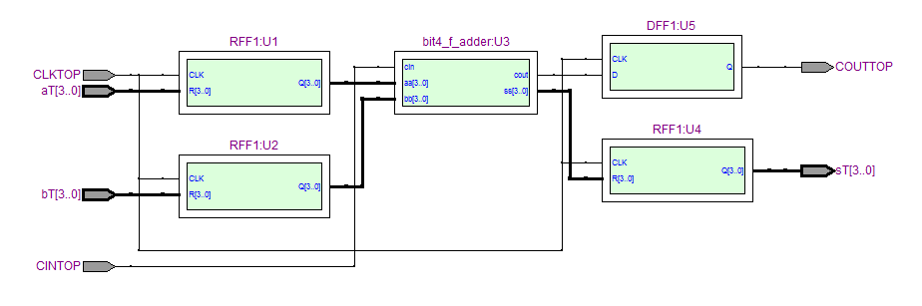
- 触发器
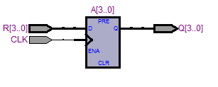
- 四位加法器及全加器
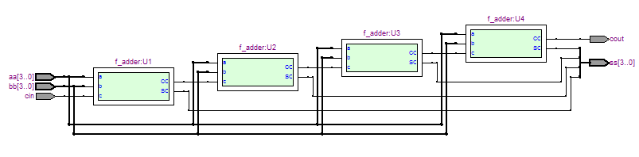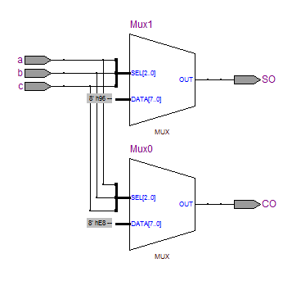

- 时序仿真波形图
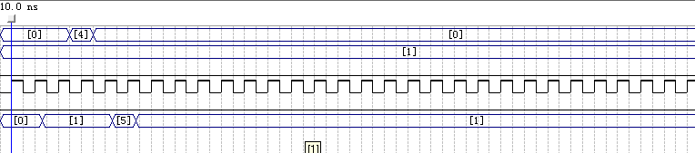
- 硬件测试及结果
